**AWS Organizations & Consolidated Billing**

**What is AWS Organizations?**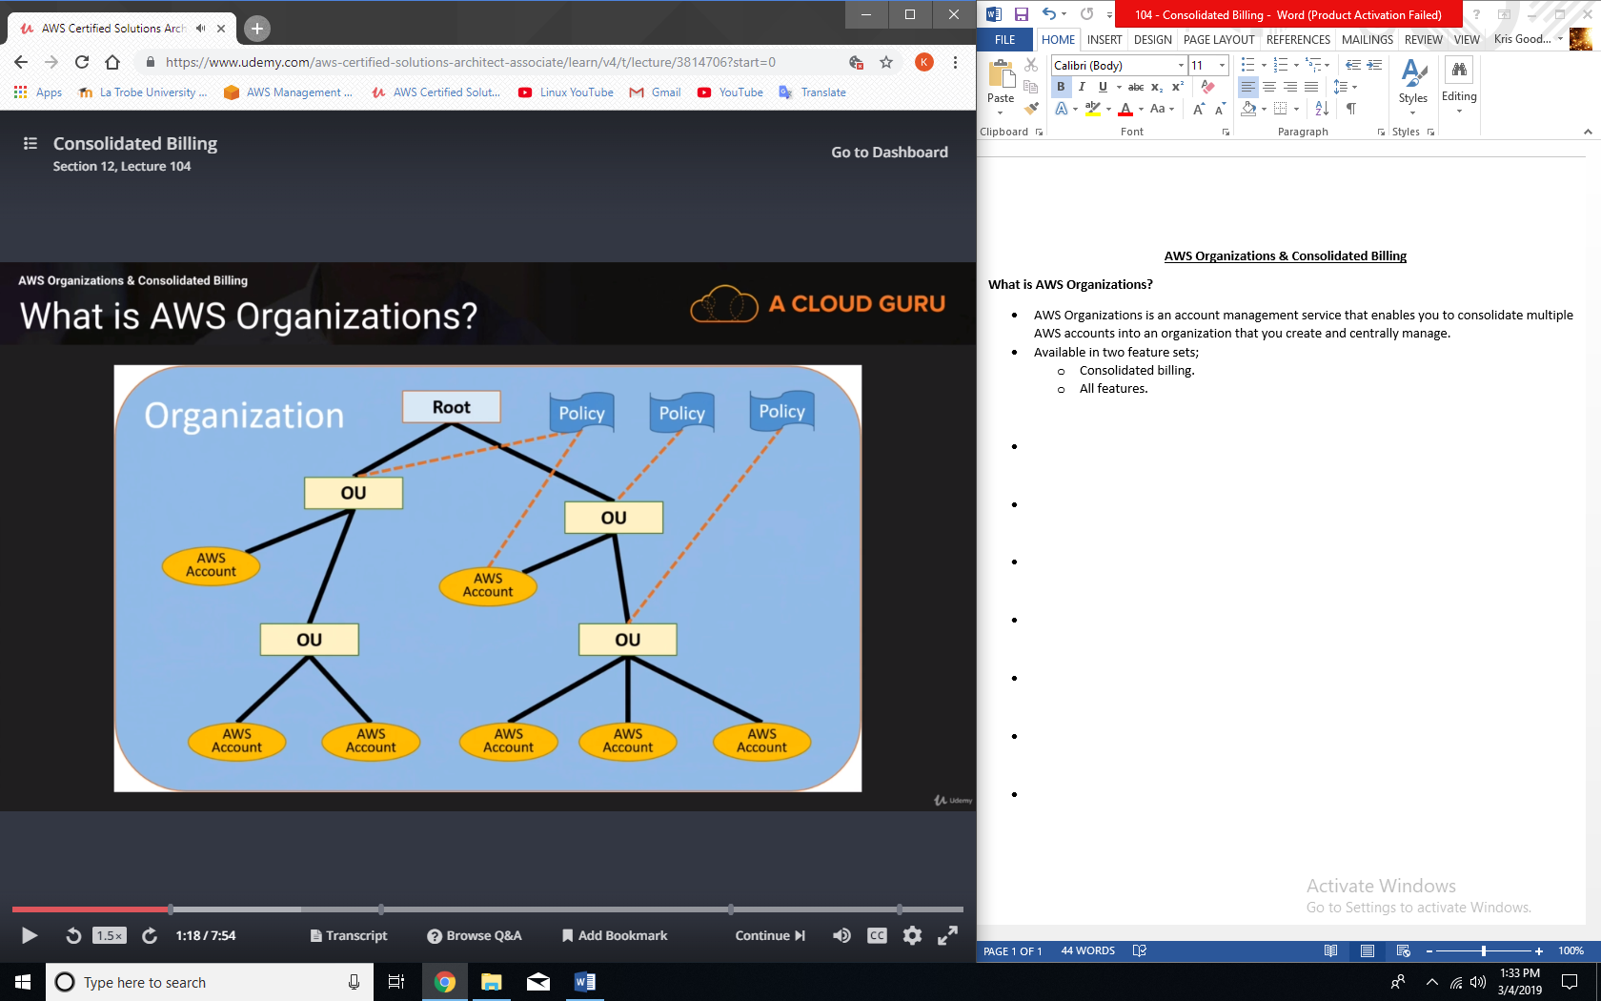OU = Organization Units

* AWS Organizations is an account management service that enables you to consolidate multiple AWS accounts into an organization that you create and centrally manage.
* Available in two feature sets;
  + Consolidated billing.
  + All features.

**Consolidated Billing:**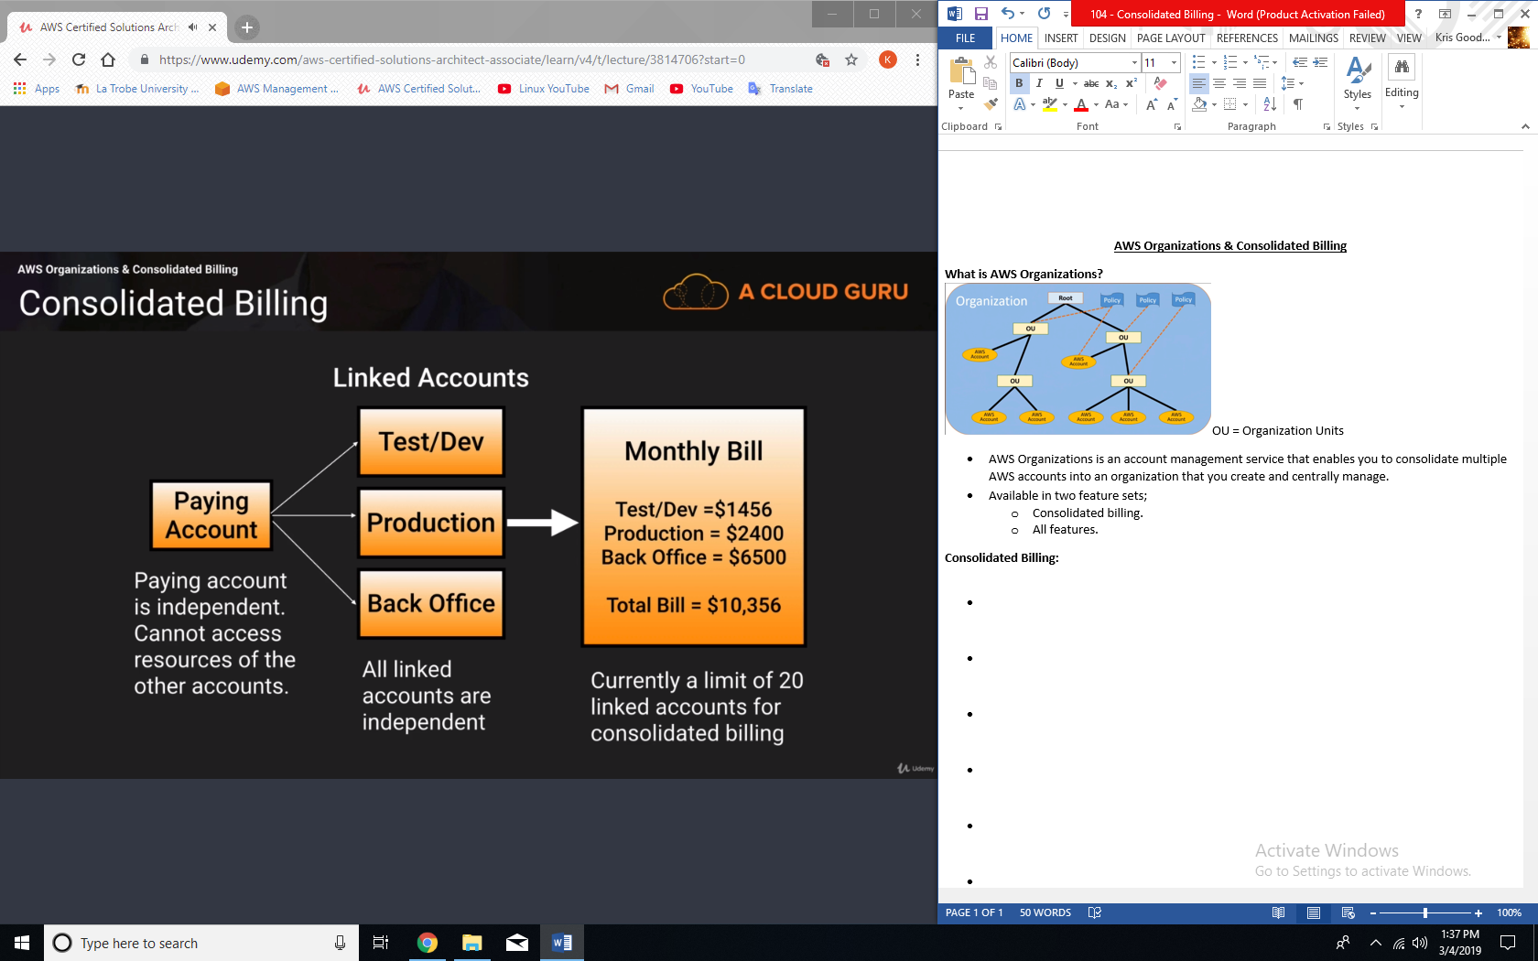

**Advantages of Consolidated Billing:**

* One bill per AWS account.
* Very easy to track charges and allocate costs.
* Volume pricing discount.

**Example:**

* Our test/dev account uses 600 GB, production uses 900 GB and back office uses 500 GB
* Without consolidated billing we would pay
  + 600 x $0.03 = $18
  + 900 x $0.03 = $27
  + 500 x $0.03 = $15
  + Total bill = $60 for 2TB of storage.
* 1TB x $0.03 = $30
* Next 1TB x 0.0295 = $29.50
* Total bill of $59.50

**Reserved EC2 instances:**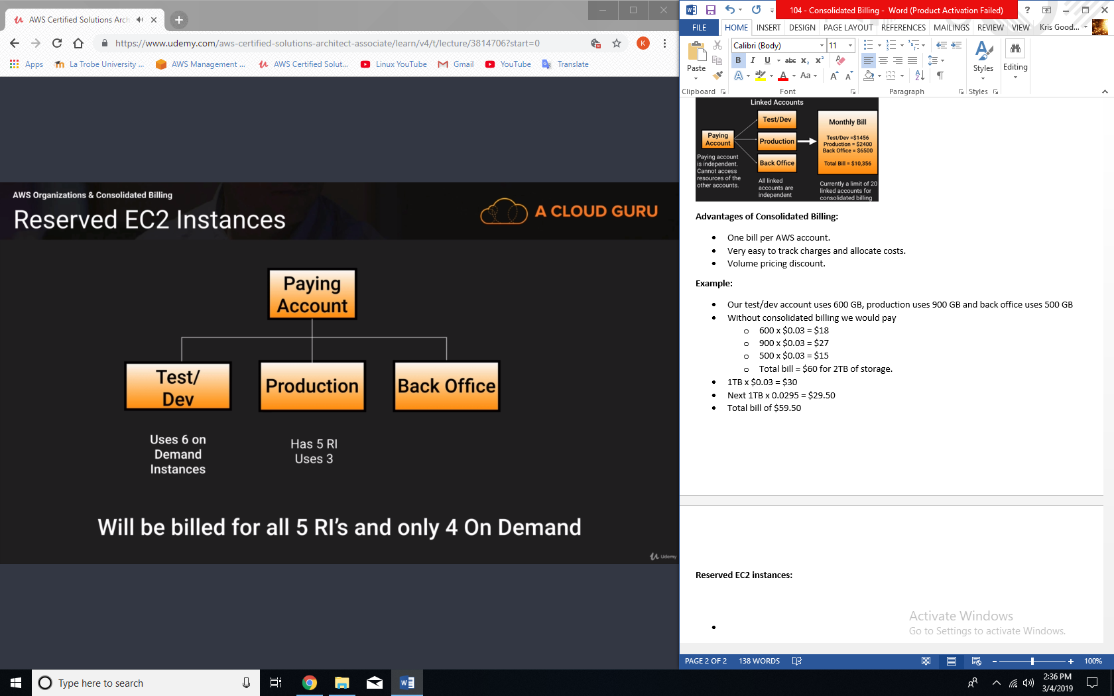

**Best Practices:**

* Always enable multi-factor authentication on root account.
* Always use a strong and complex password on root account.
* Paying account should not be used for billing purposes only. Do not deploy resources into paying account.

**Other things to note:**

* Linked accounts:
  + 20 linked accounts only.
  + To add more visit <https://aws-portal.amazon.com/gp/aws/html-forms-controller/contactus/aws-account-and-billing>
* Billing Alerts:
  + When monitoring is enabled on the paying account, the billing data for all linked accounts is included.
  + You can still create billing alerts per individual account.
* CloudTrail:
  + Per AWS account and is enabled per region.
  + Can consolidate logs using an S3 bucket
    1. Turn on CloudTrail in the paying account.
    2. Create a bucket policy that allows cross account access.
    3. Turn on CloudTrail in the other accounts and use the bucket in the paying account.

**Exam Tips:**

* Consolidated billing allows you to get volume discounts on all your accounts.
* Unused reserved instanced for EC2 are applied across the group.
* CloudTrail is on a per account and per region basis but can be aggregated in to a single bucket in the paying account.